**UPGRAD HIVE CASE STUDY**

The following steps are performed in the hive case study :

1. Connect the local machine to the master node using SSH

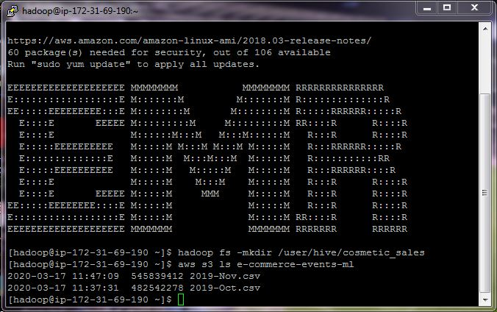

1. Create a folder name ‘Cosmetic_Sales’ in the HDFS using the following command:

***hadoop fs -mkdir /user/hive/cosmetic_sales***

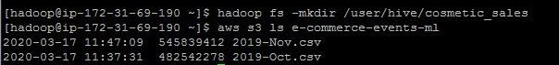

1. Import the data to the folder ‘cosmetic_sales’ in the HDFS using the following command:

***hadoop distcp s3://e-commerce-events-ml/ /user/hive/cosmetic_sales/***

1. Now we have imported the data in the HDFS. To see the imported data run the following command :

***Hadoop fs-ls /user/hive/cosmetic_sales***

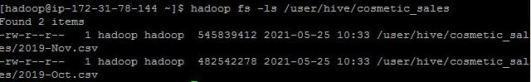

**Here,we can see that both the files are uploaded in the HDFS**

1. Launch the Hive Service .For this run the command “***hive”***
2. Creating and using the database named ‘cosmetic_sales’ using the following query :

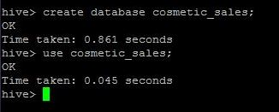

1. Create the external table by using the following query:

***create table if not exists sales_table(event_time timestamp, event_type string, product_id string, category_id string, category_code string, brand string, price float, user_id bigint, user_session string) row format serde 'org.apache.hadoop.hive.serde2.OpenCSVSerde' stored as textfile location '/user/hive/cosmetic_sales/' tblproperties("skip.header.line.count"="1");***

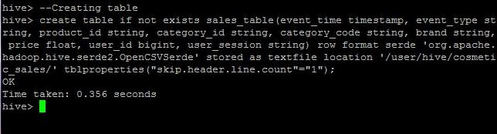

1. Describe the table ‘sales_table’ by using the following query :

***Describe sales_table ;***

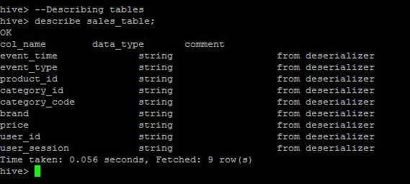

1. To show the headers for all the queries use the following query :

***set hive.cli.print.header=true ;***

1. Create the partitioning and bucketing using the following command :

***create table cosmetic_bucket(event_time timestamp, product_id string, category_id string, category_code string, brand string, price float, user_id bigint, user_session string) partitioned by(event_type string) clustered by(category_code) into 12 buckets row format serde 'org.apache.hadoop.hive.serde2.OpenCSVSerde' stored as textfile;***

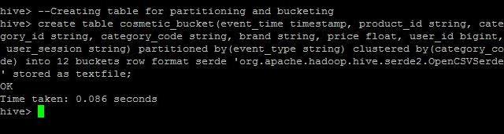

11) Set dynamic partitioning mode to nonstrict using the following command :

***set hive.exec.dynamic.partition.mode=nonstrict ;***

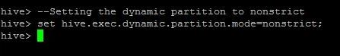

1. Load the data in the partitioned and bucketed table named ‘ext_table2019’ using the following command :

***insert into table cosmetic_bucket partition(event_type) select event_time, product_id, category_id, category_code, brand, price, user_id, user_session, event_type from sales_table;***

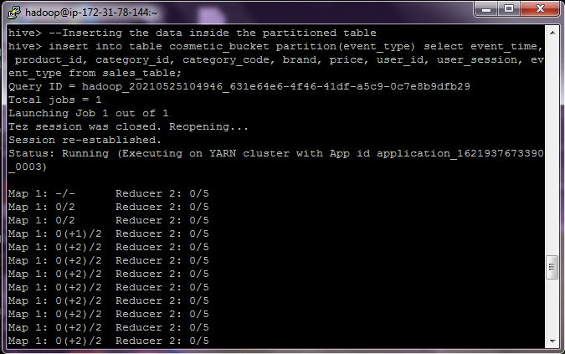

# QUERY OPTIMIZATION

We have created the partitioned and bucketed table named ‘cosmetic_bucket’ to optimize the queries. Let’s see how we can optimize queries through the example.

1. Fetching the first 10 rows of ***sales_table.***

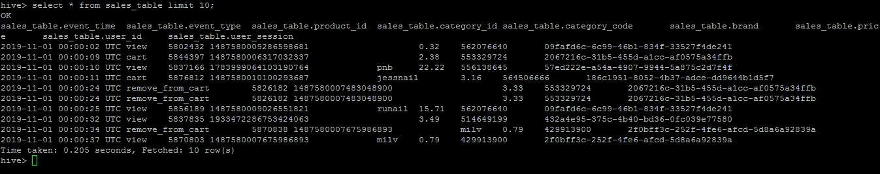

Here we can see that the time taken to execute the query in the table ‘sales_table’ is 0.205 seconds.

1. Fetching the first 10 rows of ***cosmetic_bucket.***

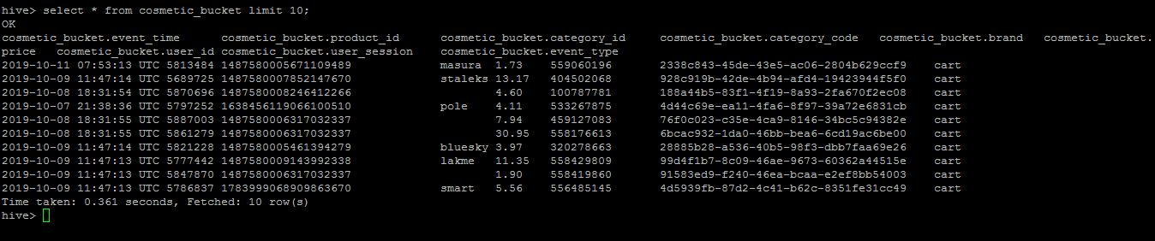

Here we can see that the time taken to execute the query in the table ‘cosmetic_bucket’ is 0.361 seconds.

**CONCLUSION:** We can conclude that the partitioned and bucketed table ‘cosmetic_bucket’ takes less time as compared to table ‘sales_table’ to execute the query**.** So now onwards, we will perform all the queries on the partitioned and bucketed table ‘cosmetic_table’.

# QUESTIONS AND ANSWERS

1. **Find the total revenue generated due to purchases made in October.**

Ans: ***select sum(price) as revenue from cosmetic_bucket where month(event_time)=10 and event_type='purchase';***

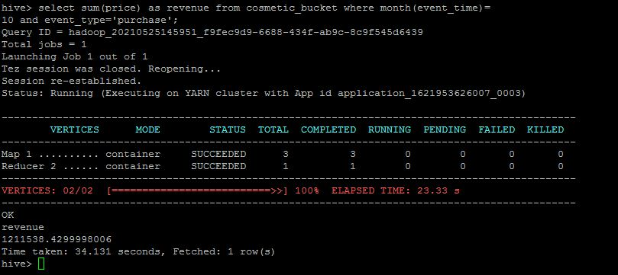

The total revenue generated due to the purchases made in October month is **1211538.4299998006 .**

1. **Write a query to yield the total sum of purchases per month in a single output.**

Ans ***select month(event_time), sum(price) from cosmetic_bucket where year(event_time)=2019 and event_type='purchase' group by month(event_time);***

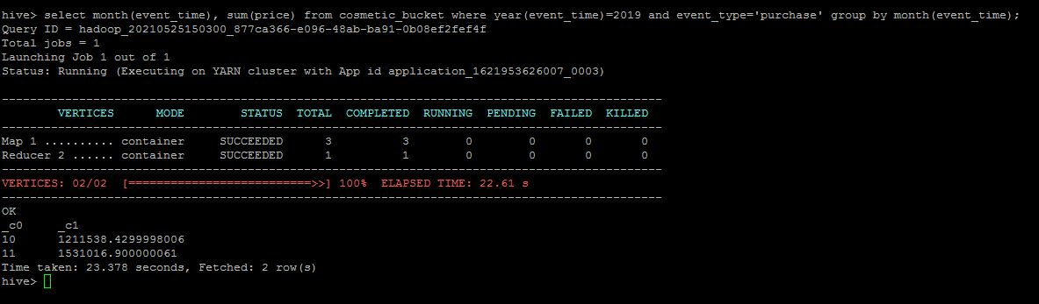

The total sum of purchases in the month of October is **1211538.4299998006** and the total sum of purchases in the month of November is **1531016.900000061 .**

1. **Write a query to find the change in revenue generated due to purchases from October to November.**

**ANS:**

***with diff_revenue as(select sum(case when month(event_time) = '10' then price else 0 end) as Oct_purchase, sum(case when month(event_time) = '11' then price else 0 end) as Nov_purchase from cosmetic_bucket where event_type= 'purchase') select (Nov_purchase - Oct_purchase) as difference_revenue from diff_revenue;***

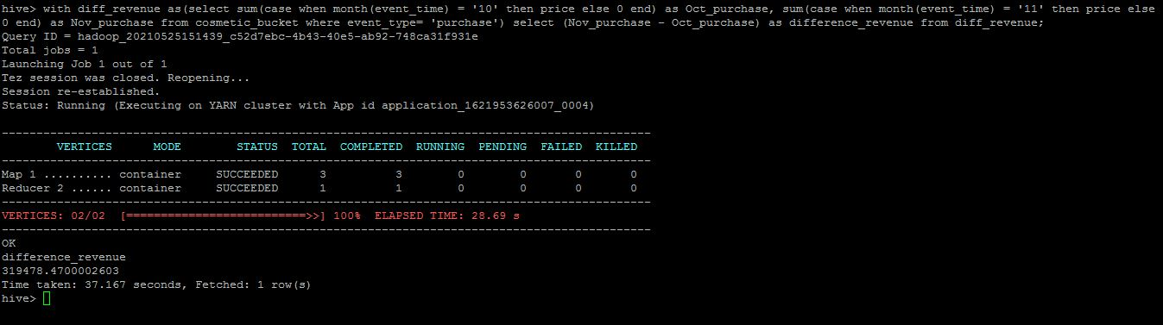

The change in revenue generated due to purchases from October to November is **319478.4700002603.**

1. **Find distinct categories of products. Categories with null category code can be ignored.**

ANS: ***select distinct(category_code) from cosmetic_bucket;***

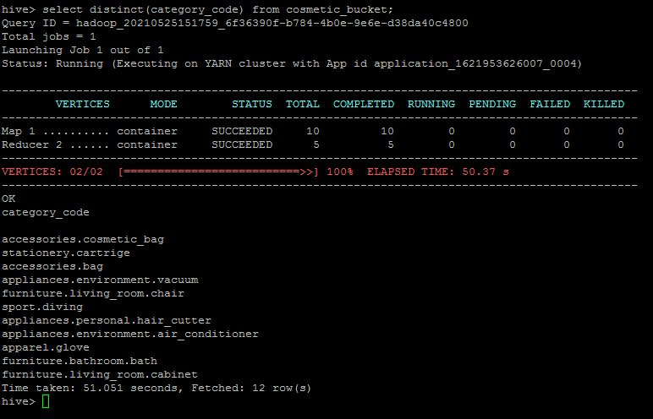

The distinct categories of the products are as follows :

1. ***Accessories.cosmetic_bag***
2. ***Stationary.cartrige***
3. ***Accessories.bag***
4. ***Appliances.environment.vacuum***
5. ***Furniture.living_room.chair***
6. ***Sport.diving***
7. ***Appliances.person.hair_cutter***
8. ***Appliances.environment.air_conditioner***
9. ***Apparel.glove***
10. ***Furniture.bathroom.bath***
11. ***Furniture.living_room.cabinet***
12. **Find the total number of products available under each category.**

***select category_code, count(product_id) as total_order from cosmetic_bucket group by category_code;***

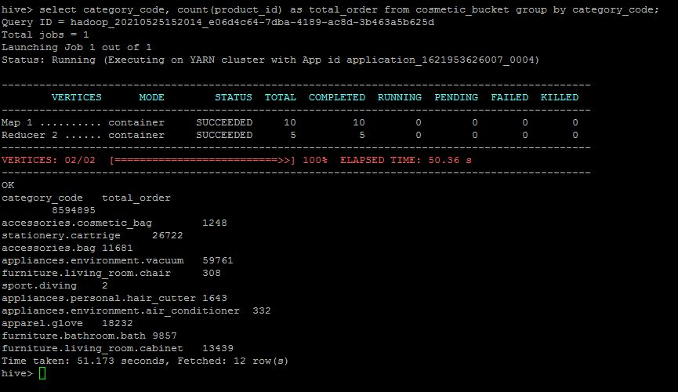

The total number of products available under each category is as follows

***: i) Accessories.cosmetic_bag - 1248***

***ii) Stationary.cartrige - 26722***

***iii) Accessories.bag – 11681***

***iv) Appliances.environment.vacuum – 59761***

***v) Furniture.living_room.chair - 308***

***vi) Sport.diving - 2***

***vii) Appliances.person.hair_cutter -1643***

***viii) Appliances.environment.air_conditioner - 332***

***ix) Apparel.glove - 18232***

***x) Furniture.bathroom.bath - 9857***

***xi) Furniture.living_room.cabinet – 13439***

1. **Which brand had the maximum sales in October and November combined?**

***select brand, sum(price) as sales from cosmetic_bucket where brand is not null and event_type='purchase' group by brand order by sales desc limit 2;***

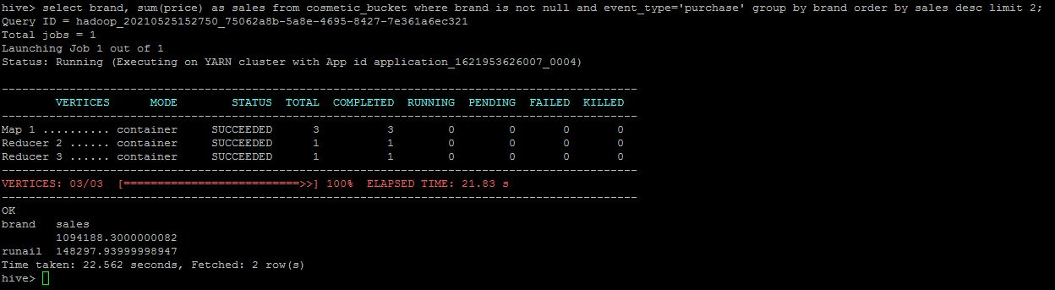

1. **Which brands increased their sales from October to November?**

***select a.brand from(select brand, sum(price) as sales from cosmetic_bucket where brand <>'' and month(event_time)=10 group by brand) as a inner join (select brand,sum(price) as sales from cosmetic_bucket where brand !='' and month(event_time)=11 group by brand) as b on a.brand=b.brand where b.sales-a.sales>0 limit 5 ;***

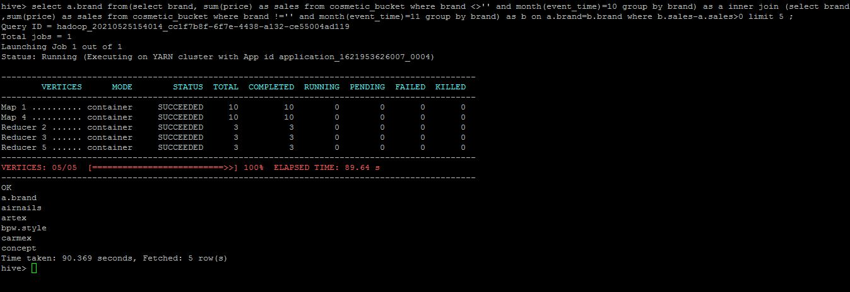

The following top 5 brands increased their sales from October to November:

1. ***airnails***
2. ***artex***
3. ***bpw.style***
4. ***carmex***
5. ***concept***
6. **Your company wants to reward the top 10 users of its website with a Golden Customer plan. Write a query to generate a list of top 10 users who spend the most.**

***select user_id, sum(price) as spend from cosmetic_bucket group by user_id order by spend limit 10;***

